1.pkts .dat buffer size= 4

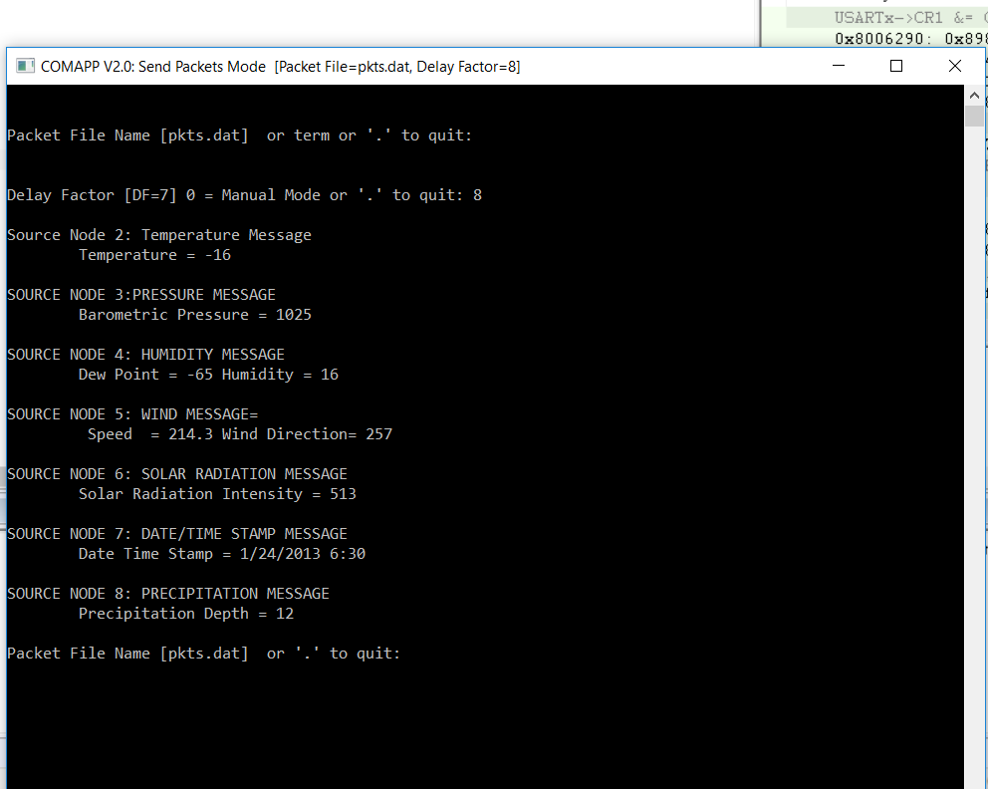

2.errs.dat ,buffer size =4

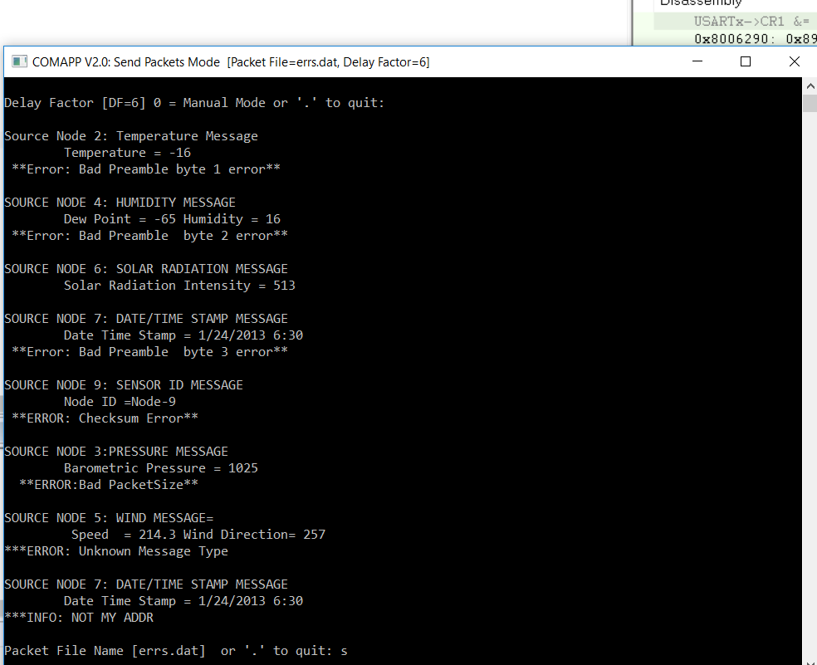

|  |  |  |
| --- | --- | --- |
|  | Buffer size |  |
|  | 4 bytes | 128 bytes |
| Program 4 | 7 | 6 |

|  |  |
| --- | --- |
| Program 1 | 50 |